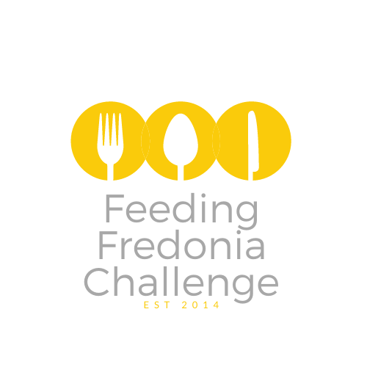

Medical/Dental/Health
Daniel Faltisco, DDS
Darwin’s Health Club
Great Lakes Physician Practice
Steven Ihrig, OD
Temple Street Dental

Salon & Spa
Barbara Ann’s Hair Salon
Facial Expressions
Henry’s Hair Co.
Medusa’s Hair
Ritual Hair Salon
Salon Belle Vie
The Cutting Crew
The Hair Bar
Vacanti’s Salon
Visions of Elegance

Financial/Tax
Bahgat & Laurito-Bahgat, CPAS
Edward Jones (Joel Muth)
Gugino & Ryel Financial
Inner Lakes Federal Credit Union
M&T Bank
Rose Crino, CPA

Non-Profits
Darwin R. Barker Library
Literacy Volunteers of Chautauqua
Fredonia Presbyterian Church
St. Anthony Catholic Church
St. Joseph Catholic Church
St. Paul Lutheran Church
The Next Chapter Book Store

Retail
Cool Little Music Shop
Fresh & Fancy Floral Design Studio
Fredonia Coin & Treasure
Great Lakes Gold & Silver
Jamestown Mattress
Lady of the Lake
Pucci’s Carpet One
Rhythm & Grooves Record Store
The Sew-er’s Choice
The Home Depot

Animal Wellness
Fredonia Animal Hospital
Stacy’s Spaw

Food Industry
Dollar General (Main Street)
Domas Fare
Fred’s Food Service
Fredonia Food Mart & Deli
Om Nohm Bakery & Café
The Cakery

Insurance
Mayville Tremaine
State Farm
The Getzoni Agency

Legal
Brautigam & Grautigam, LLP
Drayo Law Offices
Eades & Militello, P.C.

Services
Chautauqua Brick Co Inc.
Colley’s Pools and Spas
Comerford Collision
Culligan
DFT Communications
Howard Hanna (Stephen Holt)
Jim’s Dry Cleaners
Midtown Realty
Surge (New to town and new to FFC!)
Sir Prints Alot

Places that don’t have the space to collect
but are supporting FFC in other ways
Bell Chiropractic
Fredonia Cycle Shop
Concord Pharmacy

