* AFFIRMATION OF FAITH
In life and in death we belong to God. Through the grace of our Lord Jesus Christ, the love of God, and the communion of the Holy Spirit, we trust in the One Triune God, the Holy One of Israel, whom alone we worship and serve.
In gratitude to God, empowered by the Spirit, we strive to serve Christ in our daily tasks and to live holy and joyful lives. With believers in every time and place, we rejoice that nothing in life or in death can separate us from the love of God in Christ Jesus our Lord. Glory be to the Father, and to the Son, and to the Holy Spirit. Amen.
From: A Brief Statement of Faith, Presbyterian Church (USA)

*Hymn No. 366 Love Divine, All Loves Excelling
Offering: Giving does not buy you God’s love—that is free. Giving simply helps keep our heat on, our ministries going, and our staff, paid.
An offering plate is found at the front of the sanctuary. You may also mail or PayPal a donation.

We affirm our faith together because as diverse as we are, as differently as we vote, as many interests as we have, we have these beliefs that we share.
Benediction is a fancy word for blessing.

Worship Notes
Some of today’s liturgy is used with permission from enfleshed
Music is printed and recorded under the CCLI #CSPL121737 & 11497292

*Charge & Benediction

*Share the Peace of Christ
Go now in peace, go now in peace,
May the love of God surround you everywhere,
Everywhere you may go.

Worship Leaders
Pastor, The Rev. Holly Clark-Porter
Music Coordinator, Lily Li
Liturgist, Susan Pepe
Clerk of Session, Sandy Johnson

ALL ARE WELCOME to a time of fellowship after the service today in the fellowship hall.
There is a sign up sheet if you would like to bring in refreshments for any future Sunday. There are instructions for making the coffee and store bought cookies are always a hit.

Give
Secure Donation
using PayPal.
Use the drop down to give to a certain fund.

Fredonia Presbyterian Church
219 Central Ave., Fredonia, NY 14063
www.fredoniapres.org
716-679-1501

Fredonia Presbyterian Church
May 22, 2022

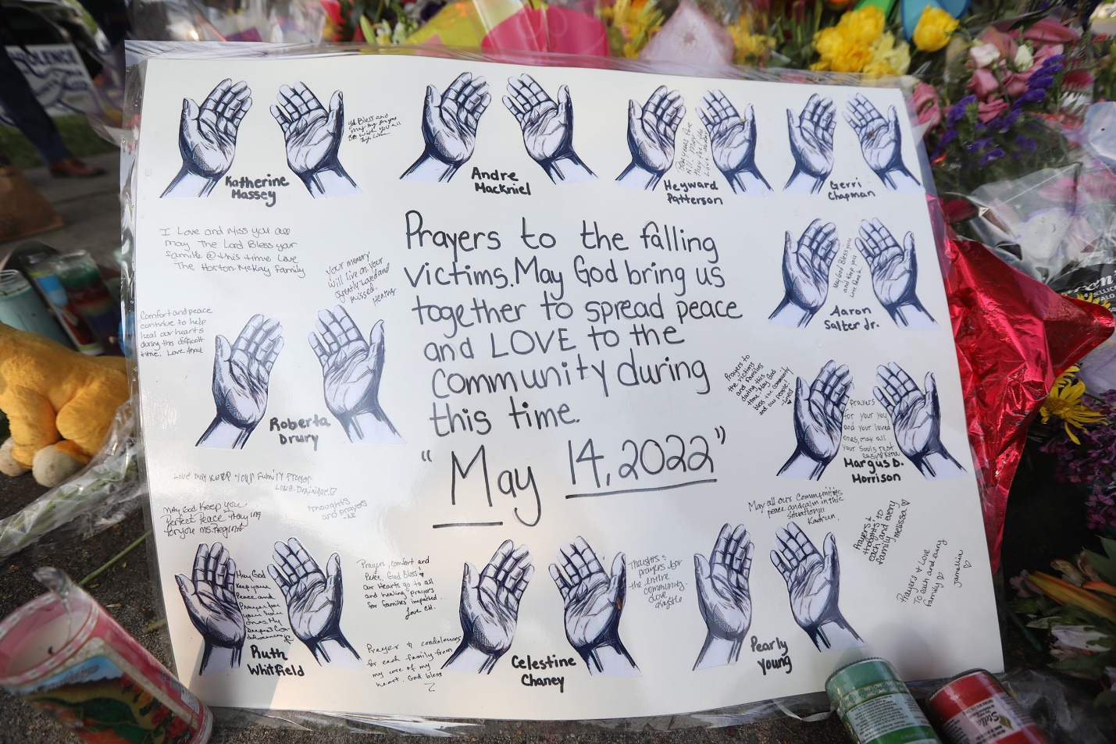
A sign with hands around each person's name who died in the mass shooting was left across from the Tops Friendly Market on Jefferson Ave. in Buffalo, NY with a message on May 16, 2022
TINA MACINTYRE-YEE/ROCHESTER DEMOCRAT AND CHRONICLE

Prepare for Worship

Welcome to worship, where God gathers us in the name of love. At FPC, we hope to be challenged by Scripture, comforted by community, and energized by service. If you’re new here or it’s been a while, we’re glad you walked in today. For more, check out the bulletin insert.
All people: toddlers, teenagers, Gen Xers, Boomers and beyond, LGBTQIA+ folx, conservative or liberal people, and those with differing abilities and mental health—all—are cherished and affirmed here.

Gather
Catch up with one another as you come in! When the chiming of the hour sounds, please keep the silence as we prepare for worship.

Reformed worship centers around the Word, both the Word of scripture and Christ as the Word incarnate. Worship, then, is our communal and individual response to the Word.

Bold text is read by the congregation in one voice.

*Please rise in body or in spirit.

Confession isn’t to prove you’re pious. It’s to help rebuild connections between you and God, you and yourself, you and others, and us and the world.

Prelude - Lily Li

Chiming of the Hour
Use this moment of silence to gather your heart and mind as we prepare for worship.

Welcome & Announcements - Rev. Holly Clark-Porter

Choral Introit

*Call to Worship - Liturgist, Susan Pepe
One: God who longs for us to sit together, sing together, and rejoice together, Hear us as we worship today: When the Wicked Ways of the world overwhelm us,
Many: Guard our spirits from resignation.
One: When oppression remains the law of the land,
Many: Fan the flames of our anger into acts of solidarity.
One: Let us gather with each other and with God --
Many: For in us and amongst us, the Spirit Lives and Moves.

*Hymn No. 354 Mine Eyes Have Seen the Glory

Unison Prayer of Dedication
May these gifts be used to build the Beloved Community through our hands of service, in the power of the Holy Spirit, and in the name of Jesus, our Messiah. Amen.

Call to Confession & Silent Confession

Prayer of Confession
We have not yet learned to love as you love.
We have spoken praise in our mouths.
When our hearts were far from you.
The gifts you gave for our peace.
We have weaponized.
Yet, even in our failings.
Your love has never failed us.
Even when we turned you away.
You still choose to make your home among us.
Our hearts are troubled.
We are enmeshed in fear.
Creation needs you.
Our families need you.
Our streets need you.
Our cities need you.
The soil needs you.
Our souls need you.
Heal us.
Forgive us.
Make us whole again. Amen.

Assurance of Pardon

Sung Response to the Assurance Hymn No. 697 Take My Life, vs 1 &2
Take my life and let it be consecrated, Lord, to thee; take my moments and my days; let them flow in ceaseless praise; let them flow in ceaseless praise.
Take my hands and let them move at the impulse of they love; take my feet and let them be swift and beautiful for thee, swift and beautiful for thee.

Word
Prayer of Illumination

Old Testament: Psalm 67 - Susan Pepe
Choral Anthem
Gospel: John 14:1-7, 18-19

Sermon

Musical Reflection - Lily Li

New Member Welcome
Brittany M. Sanford
Frank A. Valentine

Engage
Prayers of the People and The Lord’s Prayer
Our Father who art in heaven, hallowed be Thy name. Thy kingdom come, Thy will be done, on earth as it is in heaven. Give us this day our daily bread and forgive us our debts as we forgive our debtors. Lead us not into temptation but deliver us from evil. For Thine is the kingdom and power and the glory forever. Amen.
Scripture: Our pastor (usually) follows the Revised Common Lectionary, an ecumenical, Biblical reading program. This helps the Holy Spirit move into places we might otherwise miss.

The Lord’s Prayer: We use “debts and debtors” in the Lord’s Prayer. If you’re more comfortable with the “trespasses” language, please use it. Or if this prayer is meaningful to you in a different language, pray it that way. We all get to “Amen” together

